Pre Calc Name: ______________

______________ ______________

WS Assessment

Target 12

Matrices

* Operations with Matrices
* Using Reduced Row Echelon Form to Solve Linear Systems
* Evaluating and Applying Determinants
* Using Inverses of Matrices to Solve Linear Systems

HW 12 Matrices www.deltamath.com

Definition: Matrix is a rectangular array of numbers. Each number is called an ***element***

Dimension: a matrix has m rows and n columns then it is an *m x n* matrix.

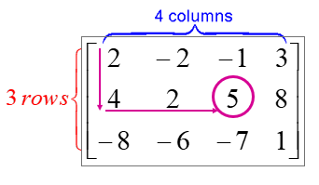

What is the dimension (size) of matrix ?

[A] = Element a2,3 = 5

Find a1,2 a3,2

**Row Operations:** There are 3 Elementary Row Operations:

* 1. Interchange two rows Ri 🡨 🡪 Rj
  2. Multiply a row by a non-zero constant kRi 🡪 Ri
  3. Add a multiple of a row to another row kRi + Rj 🡪 Rj

Given the matrix above, do the following

R1 🡨🡪R3; 5R2 🡪R2 ; -2R1+R3 🡪 R3

Identify the what row operations is performed for the following matrix

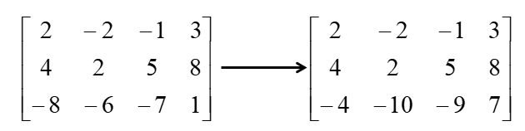What row changed?

Was it multiply by a constant?

How much was added?

Those are from where?

Now decide what is the row operation?

Row Echelon Form

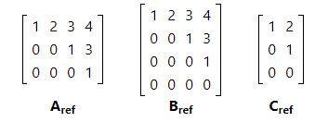A matrix is in row echelon form if:

* 1. Any rows consisting of entirely zeros occur at the bottom of the matrix
  2. For each row that does not consist entirely of zeros, the first nonzero entry is a 1
  3. As you work down the matrix the “leading 1” moves to the right.

Which matrix is in row echelon form?

|  |  |  |  |
| --- | --- | --- | --- |
| $$\left[\begin{matrix}1 & 5 & -2 & 5 \\ 0 & 4 & 3 & 2 \\ 0 & 0 & 1 & -4\end{matrix}\right]$$ | $$\left[\begin{matrix}1 & 4 & -5 & 2 \\ 0 & 0 & 1 & -2 \\ 0 & 0 & 0 & 1\end{matrix}\right]$$ | $$\left[\begin{matrix}1 & 4 & -5 & 2 \\ 0 & 1 & 1 & -2 \\ 0 & 1 & 4 & 1\end{matrix}\right]$$ | $$\left[\begin{matrix}1 & 5 & -2 & 5 \\ 0 & 1 & 4 & -3 \\ 0 & 0 & 1 & -6\end{matrix}\right]$$ |

A matrix is in **reduced row echelon form** if every entry above and below a leading 1 is 0

Which of the following is ref and rref?

|  |  |  |  |
| --- | --- | --- | --- |
| $$\left[\begin{matrix}1 & 0 & 0 & 5 \\ 0 & 1 & 0 & 4 \\ 0 & 0 & 1 & -2\end{matrix}\right]$$ | $$\left[\begin{matrix}1 & 4 & -3 & 5 \\ 0 & 1 & -5 & 4 \\ 0 & 0 & 1 & -2\end{matrix}\right]$$ | $$\left[\begin{matrix}1 & 5 & -2 & 5 \\ 0 & 1 & 4 & -3 \\ 0 & 0 & 1 & -6\end{matrix}\right]$$ | $$\left[\begin{matrix}1 & 0 & 0 & 5 \\ 0 & 1 & 0 & 3 \\ 0 & 0 & 1 & 4\end{matrix}\right]$$ |

Any matrix can be transformed into its echelon forms, using a series of elementary row operations through pivot the matrix (google?)

Identify the following row operation

$$\left[\begin{matrix}0 & 1 & 2 \\ 1 & 2 & 1 \\ 2 & 7 & 8\end{matrix}\right]→\left[\begin{matrix}1 & 2 & 1 \\ 0 & 1 & 2 \\ 2 & 7 & 8\end{matrix}\right]→\left[\begin{matrix}1 & 2 & 1 \\ 0 & 1 & 2 \\ 0 & 3 & 6\end{matrix}\right]→\left[\begin{matrix}1 & 2 & 1 \\ 0 & 1 & 2 \\ 0 & 0 & 0\end{matrix}\right]→\left[\begin{matrix}1 & 0 & -3 \\ 0 & 1 & 2 \\ 0 & 0 & 0\end{matrix}\right]$$

[A] [A1] [A2] [A3] [A4]

State your row operations and find the reduce row echelon form for this matrix, check by calculator

$$\left[\begin{matrix}1 & 2 & 3 \\ 2 & 3 & 4\end{matrix}\right]$$

Solve the system of linear equation

x + 2y = 3 Step 1: Build the augmented matrix [A|B}

2x + 3y = 4 Step 2: Do row reduce echelon on this matrix

Step 3: Write the solution – the last column

Solve the following by rref

x + 2y = 8 4x + 2y – 3z = -5

3x + 4y = -6 x + 3y – z = 11

-x + 2y = 5

**Add / Subtract** matrix

[A]+[B] = [C]  such that aij+bij= cij [A]−[B]= [D] such that aij−bij= dij

**Multiply** matrix

Requirement  If [A] is an (m × r)  matrix [B] is an (r × n) matrix, then the product

matrix [A][B  ] is an (m × n)

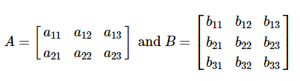Given

the product matrix will be

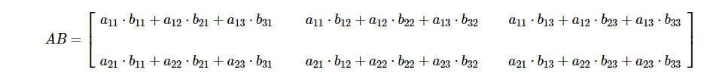

Multiply [A][B]

https://media1.shmoop.com/images/algebra-ii/alg2_matrices_latek_230.png https://media1.shmoop.com/images/algebra-ii/alg2_matrices_latek_238.png

An outbreak of Chicken Pox hit the local public schools. Approximately **15%** of the male and female juniors and **25%** of the male and female seniors are currently healthy, **35%** of the male and female juniors and **30%** of the male and female seniors are currently sick, and **50%** of the male and female juniors and **45%** of the male and female seniors are carriers of Chicken Pox.

There are **100** male juniors, **80** male seniors, **120** female juniors, and **100** female seniors.

Using two matrices and one matrix equation, find out **how many males and how many females (don’t need to divide by class) are healthy, sick, and carriers.**

|  |  |  |
| --- | --- | --- |
| Determinants det([A]) | The matrix Inverse [A]-1 | The Identity matrix |
|  |  | [A][A]-1 = [I]  [A]-1 [A] = [I] |

Find the determinant and inverse of the matrix, check by identity and calculator.

$\left[A\right]=\left[\begin{matrix}2 & 3 \\ 1 & -4\end{matrix}\right]$ $\left[A\right]=\left[\begin{matrix}? & ? \\ ? & ?\end{matrix}\right]$ You fill in

Matrix Equation Given [A][X] = [B] then [X] = [A]-1[B]

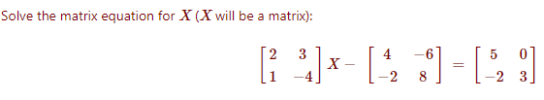

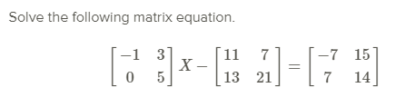

**Target 12 Assessment**

Solve the system using reduce row echelon and inverse matrix. Show all step

x + 2y +3x = 0

3x + 4y + 7z = 0

6x + 5y + 9z = 11

Solve the matrix equation. Show all work (no matrix calculator use)

